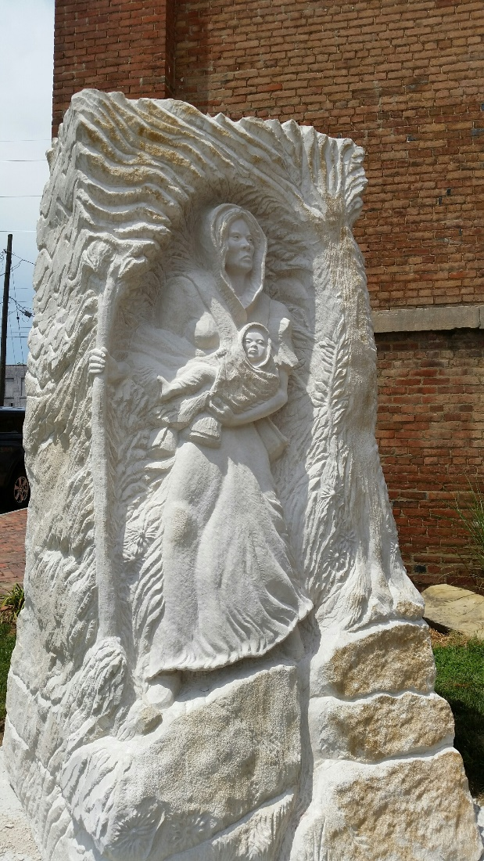
Statue of escaped slave Lucy Higgs Nichols with her baby daughter Mona located at The Town Clock Church
Sculpture by Dave Ruckman of New Albany, Indiana

