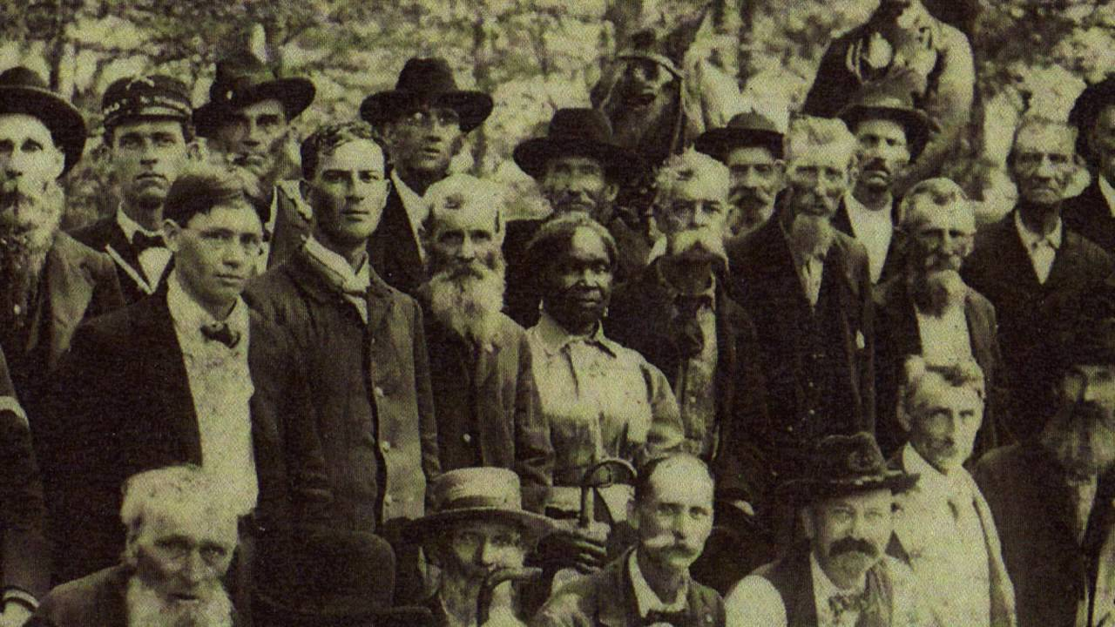

Old Civil War 23rd Indiana Volunteer Regiment
Lucy Higgs Nichols surrounded by her fellow members of the Sanderson Post of The Grand Army of the Republic
Circa late 1800s

