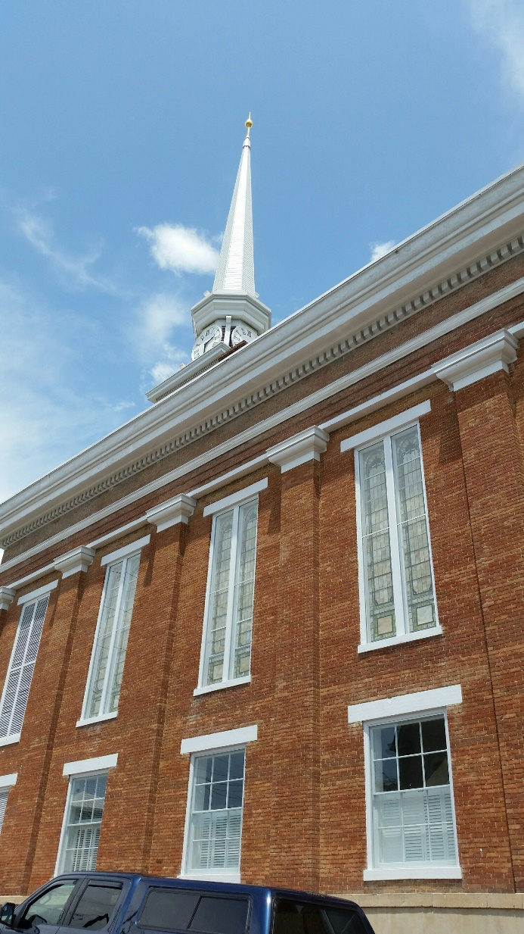
Formerly the 2nd Presbyterian Church which was the site of the hidden Underground Railroad from 1852 until 1865

